RESSAC
Case study: DAL A FPGA implemented in a product with no SW part.

Domain: HW

Context and purpose

In the context of µXAV EPS design some HW sub-system/equipment requests a complex component of type FPGA to be implemented.

The purpose of this usecase is to describe a complex component development flow as part of a product development.
To simplify the demonstration, no SW exists into this product (pure HW approach).

The FPGA is a classic one, without additional level of complexity such as embedded IP or internal COTS.

No advanced verification methods (assertion based, model based, formal approach …) are used during this development (to be managed through another usecase slice)

Product & Board Process development is out of the scope of this case study, which will emphasize on FPGA development itself.
Product & Board Process will be described in another usecase slice, taking credit from the current FPGA usecase.

This usecase is based on actual projects that embed partially the proposed process streamlining.

Expected benefits
Streamlined aspects of the proposed process
- Remove the FPGA Specification and intermediate Specification between FPGA & product level specification, including associated activities like traceability, validation & reviews, CM & PA.

- Take credit from product level verification for FPGA physical test, removing dedicated FPGA dedicated physical verification and associated reviews, CM & PA.

- Removing the FPGA Verification intermediate step between Verification procedures (textual) & Test scenarios (tool inputs).

Particularities:
- FPGA complex but not highly complex (no COTS, no IP).
- Integrated Product /Board/FPGA Team.
- Product functionality is mainly performed by the FPGA.
Current standards issues:

Applicable standards: DO254, EASA CM - SWCEH – 001 (AEH), A(M)C 20-152A

Difficulties to apply this approach in application of current standards:
There is no blocking point regarding the current standards, only some interpretation to be carefully managed and discussed with authorities’ representative.

- Gap on DRL in Table A-1 vs. HW Lifecycle data.
- EASA CM – SWCEH – 001 recognizes DAL D process evidences for product is sufficient , while process of the FPGA is expected to be DAL A (product process should be DAL A compliant to be able to take credit of product level activities).

Compliance demonstration could be based on
- Some DO-254 data life cycle and associated activities are merged without lowering the quality.
- Add DAL A objectives to product development process to reconcile with FPGA DAL A Development process.

Process description

This process is based on classical Hardware and FPGA development processes.
Taking profit of a joined team for Product, board and FPGA design, some redundant activities have been removed or merged to create a new process more safe (due to integrated team) and less consuming.
This streamlining affects mainly FPGA requirement capture and V&V activities.

Life cycle overview
The following figure describes product development process, including FPGA related process

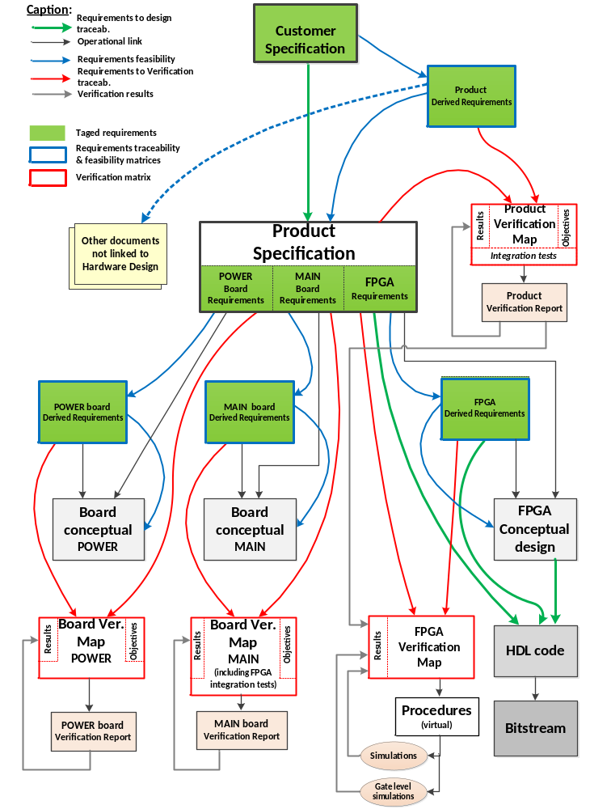

Planning Process

Typically the first process/activity described should be the planning process. It produces a set of plans and possibly applicable standards and guidelines. The plans describe the life cycle, activities, I/O, methods, environments, responsibilities, error sources and classes.

In the scope of this use case, the planning process is limited to the present document. It is assumed that some development standards are also developed.

Product Requirement Capture & Architectural Design

This process includes the following activities:
- Product specification capture
- Product architecture definition
- Product functional specification review

Product functional specification capture
Inputs:
Customer needs (EPS specification)
others sources (safety requirements, design choices, design constraints, best practices, assumptions…)
Supplier internal requirement capture standard

Outputs:
Product Specification
Traceability matrix

Method and environment:
Exchanges with stakeholders,
Development environment for HW functional allocation.

Responsibility:
Product Engineer

Description:
- Capture of Customer specification from customer needs and others sources, using requirement capture standards in order to generate Product Specification
- Identification of functions as part of Product Specification
- Generate a Traceability Matrix between Product specification and customer needs

Errors | Means of detection
Product specification is not correct with regards to customer needs  Product specification is not complete with regards to customer needs | Architecture activity to mature the customer needs 1.2.2  Specification review/Validation activities (including safety assessment).1.2.3

Product architecture definition
Inputs:
Customer needs,
Product Specification
Internal standards
Others sources (safety requirements, design choices, design constraints, best practices, assumptions…)
Supplier internal requirement capture standard

Outputs:
Updated Product Specification including functional allocation to FPGA
Product Derived Specification

Method and environment:
Exchanges with stakeholders, no specific environment
.

Responsibility:
Product Engineer
Customer representative
FPGA Designer
Verification eng.
Safety Eng.

Description:
- Definition of the Product architecture, using internal standards, internal best practices with respect to safety requirements as part of the product specification
- Close interaction with customer and other sources to mature expression of customer needs
- Functional decomposition and mapping
- Allocation of functions to Power & Main boards, as part of the product specification
- Allocation of functions to FPGA, hosted on the Main board as part of the product specification
- Creation of Derived Requirements in Product Derived Specification (not requested by Customer, from architectural definition and external sources requests)

Errors | Means of detection
Product specification is not correct with regards to user needs  Product specification is not complete with regards to user needs  Unacceptable Safety impact of added functionality and constraints (e.g. excessive complexity, non-determinist solution)  Allocation impossible to implement in FPGA  Lack of observability of FPGA content (black box) due to too high level of integration/Complexity | Specification review/Validation activities (including customer assessment). 1.2.3

Product specification review
Inputs:
Customer Specification need,
Product Specification (including architecture and function allocation)
Product Derived Specification,
Traceability matrix (Customer Specification <-> Product Specification),

Outputs:
SoC specification review report
Safety acceptance for Derived requirement

Method and environment:
Review standard, procedure and checklist

Responsibility:
Product design Engineer
Product Verification Engineer
Safety team
Customer representative
FPGA designer
FPGA Verification Engineer

Description:
- Independent review of the product functional specification with regards to the customer needs
- Independent review of the Product architecture including function allocation (internal standards, internal best practices with respect to safety requirements.)
- Ensure that customer needs are all captured by assessing a traceability matrix (customer representative is part of this review).
- Ensure that Product requirements are complete, correct, unambiguous, verifiable, and achievable based on checklist.
- Ensure that Product Derived requirements are identified, and Safety impact analysis accepted by Safety Engineer &/or Customer.

Errors | Means of detection
Lack of evidence of an under control review process | Use of dedicated standard and procedure for review  Person in charge of these activities have the correct skills

Note: There is a Board level Development process but not in the scope of this case study. We address only FPGA development process in this case study.

FPGA Design:

This process includes the following activities:
- FPGA Conceptual & Detailed Design
- VHDL code generation
- FPGA implementation

FPGA Conceptual & Detailed Design
Inputs:
requirements allocated to FPGA (part of Product specification)
Internal standards for FPGA

Outputs:
Conceptual & Detailed Design document (including allocation matrix),
FPGA Derived Requirement document

Method and environment:
no specific environment

Responsibility:
Design Engineer

Description:
- Architecture/Block Diagram of FPGA with allocation of Requirements to internal blocks
- Functional Description of blocks (inputs, outputs, interfaces, behavior)
- Definition of Clock Tree, Reset mechanism.
- Definition of FPGA constraints, pinout
- Definition of Testability features if necessary (e.g. test port)
- Identification of FPGA derived requirements in case of additional functionality not requested at product level (including internal interfaces and communication protocols).
- Analysis of Safety impact for FPGA derived requirements by Safety Engineer &/or Customer.
- Review of Conceptual & Detailed Design document

Errors | Means of detection
Block description is not correct with regards to covered requirements  Error in allocation  Architecture not achievable or not testable | Traceability between block Diagram & Requirements  Independent Review of the outputs
Additional features and constraints have unacceptable safety impact | Independent Review of the outputs including safety analysis of derived requirement

VHDL code generation
Inputs:
requirements allocated to FPGA (part of Product specification)
FPGA Derived Requirement document,
Conceptual & Detailed Design document.

Outputs:
VHDL Source Code,
constraint file,
pinout file.

Method and environment:
Internal Design and coding Standards
Coding rule checker tool (qualified as per DO254)

Responsibility:
FPGA Designer.

Description:
- Manual writing of VHDL code, with embedded traceability with regards to FPGA requirements (allocated and derived)
- Manual writing of constraint & pinout files from related FPGA requirements (allocated and/or derived)
- Code review (including coding rule check and consistency check between code, conceptual design and specification)

Errors | Means of detection
Error on implementation of Requirements & Conceptual/Detailed Design | Perform Code review vs Requirement/Conceptual/Detailed Design & Design Standard.  Perform virtual verification activities (simulation) 1.4
Error on Design rules Defined in the Coding Standard (Clocked process, positive clock edge, resynchronization of input signal / Clock Domain crossing signal….) | Implementation reports analysis 1.3.3  Perform virtual verification activities (simulation) 1.4
Additional code not traced to a capture functionality | Perform elemental analysis (code coverage during virtual verification) 1.4

FPGA Implementation
Inputs:
VHDL source code,
constraints & pinout files.

Outputs:
PostLayout Netlist
Bitstream (executable code),
Warning & Error Synthesis & P/R tools,
pinout mapping file, Usage metrics,
Static Timing Analysis (STA)
Power Consumption simulation.

Method and environment:
internal standard & FPGA Manufacturer Tools.

Responsibility:
FPGA Designer

Description:
- Generate implementation data (executable/bitstream) from the VHDL source code applying constraint and pinout files, using dedicated Synthesis and Place & Route Tools
- Generate intermediate time accurate model (object code/ postlayout netlist)
- Generate automatic reports and analysis related to timing, pinout, power and implementation process
- Analysis of these reports to detect any implementation error or discrepancy.

Errors | Means of detection
Implementation not achievable | Use of coding and design rules to limit risk 1.3.2
Implementation doesn’t fit all constraints (timing, operating conditions) | Product Test activities 1.4.3  Review of STA results
some unexpected features have been added | Use of design rules dedicated to tool usage to limit risk 1.3.2  Review of Tool reports

Verification of the design

This process includes the following activities :
- FPGA virtual procedure generation
- FPGA simulation
- Product verification

FPGA virtual verification procedures generation
Inputs:
Product specification & Product Derived Specification requirements allocated to FPGA.

Outputs:
FPGA Verification procedures (Device Virtual Verification Procedures),
Traceability data (Device Verification Matrix)

Method and environment:
internal Verification Standard (Verification Review guide and checklist)

Responsibility:
Design Engineer

Description:
- Selection of Verification Method by Requirement
- Manual write of Verification procedure with scenario, including:
  - Initial conditions,
  - covered FPGA requirements
  - Objectives
  - Scenario, Pass/Failed Criteria
  - Environment description
- Generation of Requirement Verification Coverage matrix (Device Verification Matrix)
- Procedure and traceability matrix review
Note: procedures are expressed in a language that can be interpreted by simulation tool and is sufficiently documented to be used as a support for a procedure review.

Errors | Means of detection
Incomplete coverage of the requirements  Foreseeable conditions not covered | Procedure and traceability matrix reviewed by independent peer (could be the designer)  Robustness cases to be taken in account

FPGA virtual verification
Inputs:
FPGA Verification Procedures,
VHDL Source Code

Outputs:
Verification results (Device Virtual Verification Results), Code Coverage Results.

Method and environment:
internal Verification Standard (Verification Review guide and checklist),
Simulation Environment Tool & scripts.

Responsibility:
FPGA Verification Engineer.

Description:
- Execution of Verification procedure with scenario, with Code Coverage enabled (Elemental analysis).
- Identification and classification of failed test results (failure source identification and mitigation action managed thru change process)
- Identification and justification/mitigation of uncovered element detected by code coverage process.(identification of issue source could be incomplete procedure, unused code, code not associated to a requirement, redundancy structure for robustness purpose)
- Review of verification results

Errors | Means of detection
Incomplete coverage of the requirements not detected | Elemental analysis report
Failed success criteria not detected, reported, analyzed | 1.4.1 procedure review  Failed are tracked by change process (PR)
Foreseeable conditions not covered  Stress error : functions are never verified simultaneously and without sufficient set of input data (miss corner case, stress case …) | 1.4.1 procedure review  Remaining errors (especially stress and corner cases will be detected during physical test) 1.4.3

Product test
Inputs:
Product Specification ‘including requirements allocated to FPGA),
PostLayout Netlist
Product Derived Requirement document.
FPGA Derived Requirement document,

Outputs:
Product Verification procedures
Traceability (Product and FPGA Verification Matrix versus test procedures)
Product verification results

Method and environment:
internal Verification Standard (Verification Review guide and checklist)
Testbench,
tools
Representative environment of the product

Responsibility:
Product Verification Engineer.

Description:
- Relevance of Verification Method (test / analysis)by Product Requirement
=> by construction FPGA requirements are a subset of product requirements (except FPGA derived requirements)

- Manual write of Test procedure with scenario, including:
  - Initial conditions,
  - Tracing Product requirements
  - Objectives
  - Scenario
  - Pass/Failed Criteria
- Product Requirement Verification Coverage
=> by construction FPGA requirements are a subset of product requirements (except FPGA derived requirements)
- FPGA derived Verification coverage
- Review of procedures
- Execution of Test procedure
- Perform the analysis
- Identification and classification of failed verification results (failure root cause and proposal to mitigate this failure, managed thru change process). Failure root cause could be located in verification procedure, pass/fail criteria, incomplete or incorrect requirement)
- In case of FPGA requirements not fully covered due to physical test limitation, perform Post/layout Virtual Verification (-> same activity than1.4.2 but applied on postlayout netlist in place of source code).

Errors | Means of detection
Verification procedure does not fully cover the related requirements of Top Level under verification  Undetected corner cases due to insufficient representability of environment | Procedure review by independent peer  Verification result review

Artefacts examples:

<To provide actual extracts of data to clarify the key points of the proposed processes.>

